HPLC/Mass spec

High performance liquid chromatography coupled to mass spectrometry

One of the most important analytical systems in use in laboratories today is the coupling of HPLC (high performance liquid chromatography) with MS (mass spectrometry). This system is used in a wide range of situations which include the pharmaceutical, environmental, biological and food industries. The HPLC system separates the components of mixtures and the MS measures their molecular weights (relative molecular masses). This powerful technique is sometimes referred to by yet another abbreviation, LCMS – Liquid Chromatography Mass Spectrometry.

The two techniques of HPLC and MS are very different and are essentially just joined together by a capillary tube - although there are a few technical complications.
The diagram below shows the standard layout of an HPLC system.
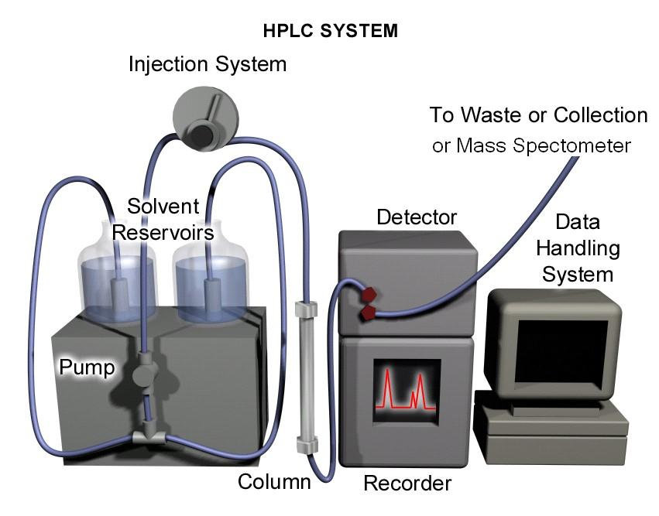

The HPLC system consists of a number of important components which include the solvent, pump, injection system, column, detector, recorder and data handling system.

The Components of an HPLC system

Solvent
The solvent is usually referred to as the mobile phase (it is moving). Typically a combination of water mixed with an organic solvent, such as acetonitrile or methanol, is used.

Pump
The pump pushes the mobile phase from the solvent reservoirs through the column to the detector under high pressure, typically 100-200 bar.

Injection system
The injection system is where a small volume of the sample under investigation is injected into the flow of the solvent. The solvent transports the sample as a discrete narrow band to the column. Usually, the injection system is part of a robotic autosampler which is used to hold a series of samples until the system is ready to inject them.

Column
The column is where the separation of a mixture is performed. It is a hollow, smooth-walled steel tube which is packed with spherical porous particles known as the stationary phase. The molecules in the mixture interact with the stationary phase; and it is these interactions that bring about the separation of the mixture into its components.

HPLC Stationary Phase
The stationary phase (column packing) used in this HPLC technique consists of very small spherical particles (typically 3µm to 5µm diameter for analytical HPLC), which are packed very tightly within a steel tube.
Although not to scale, Figure 1a shows, what the cross section of a particle would look like. The diagram shows that the particle is a honeycomb of pores. Most of the surface area of the particle is within the pores.
The particle is predominately composed of silica, SiO₂ - a glass-like material that provides the underlying support structure. The surface of the silica (both on the outside of the particle and within the pores) is covered with a layer of organic molecules which are chemically bonded to the silica surface. This fixed organic layer is often referred to as the bonded phase.

A B
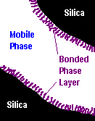

Figure 1
A: Cross section of a stationary phase particle B: Expanded section of a pore.

If one of the pores were magnified (Figure 1B), the structure of the organic layer would appear like threads which are attached to the silica surface.

In this type of chromatography, the most commonly used bonded phase is alkyl chains of 18 carbon atoms “C18”. However, other phases include C8, phenyl, cyano and many other functional groups.

Figure 2 shows the difference between “normal” silica with surface OH groups and silica with C18 chains attached. The bulk of the silica is a 3-dimensional array of covalently bonded alternating silicon and oxygen atoms. The gross structure has similarities to the bonding in diamond (-Si-O-Si- instead of -C-C- ).
Figure 2 Comparison of “normal” silica and C18 silica.

Altering the surface chemistry (i.e. the bonded phase) allows different types of interaction with the molecules of the mixture in the mobile phase. Therefore different separations can be achieved. For example, by using chains that contain a chiral centre (asymmetric centre) it is even possible to separate mixtures of optically active compounds (chiral mixtures).

Detector

The detector on an HPLC system must be able to monitor the separated components of a sample as they flow off (“elute” from) the column. A non-specific detector is required and Ultra Violet detection is the most suitable method for this purpose.

The UV detector works because most organic compounds of interest absorb light in the UV range of the electromagnetic spectrum (200 to 360 nm). The detector contains a flow cell (Figure 3), through which light from a UV lamp is passed. The solvent flow from the column travels through the flow cell and the absorption of light by is measured at selected wavelengths. When a component of a mixture passes through the flow cell it will absorb more UV light than the solvent alone and this is registered as a peak on the chromatogram. The solvent flows through a Z-shaped path to maximise the UV light absorption along the whole diagonal of the Z.
to UV
detector
Figure 3 Schematic diagram of a flow cell.

To be detected by this technique, compounds need to absorb UV light. Therefore compounds must generally have a degree of unsaturation. Those with alternating double and single bonds usually give stronger absorption.

typical structural units | UV absorption at | typical structures | UV absorption at
 | 175nm |  | 254nm
 | 173nm |  | 235nm
 | 305nm |  | 217nm
 | 300nm |  | 263nm

The most useful type of UV detector is called a Diode Array Detector (DAD). This detector captures the absorbance of all wavelengths across a spectrum simultaneously. The transmitted light from the flow cell is split into individual wavelengths and this spectrum falls onto an array of diodes, each of which monitors a specific wavelength. The selected wavelengths are then either displayed individually, or are summed, and the total output is reported on a chromatogram. A typical chromatogram is shown below (Figure 4). The x-axis represents time from the injection of the original sample. The y-axis is UV absorption (the taller the peak, the greater the absorption). Generally, the area under a peak is proportional to the amount of compound present (but there are exceptions).

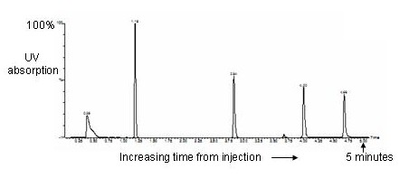

Figure 4 A typical HPLC chromatogram

How does Chromatography work?
Reverse Phase Chromatography

All chromatographic systems are based on how the molecules in a solution (the solute) interact with the stationary phase and with the solvent. The solute becomes “partitioned” between the solvent and the stationary phase. This relates to the relative amounts of time that a solute molecule spends on the stationary phase, as opposed to in solution in the solvent. Different compounds will “like” the stationary phase more than others. They have different affinities. They will therefore be adsorbed for varying times. This difference in behaviour of solutes causes mixtures to separate on the column.

To visualise the separation consider Figure 5. A mixture comprising two compounds X and Y is introduced in the mobile phase. Component X has a greater affinity for the stationary phase than Y. Compound X will therefore adsorb onto the stationary phase for a longer time than Y. Whilst components are adsorbed on the stationary phase their movement along the column stops. Component Y spends less time on the stationary phase and more time in the mobile phase than component X and is therefore moving forward along the column at a faster rate. Consequently, component Y is eluted from (comes off) the column first, followed by component X. An animation can be viewed on the web site.

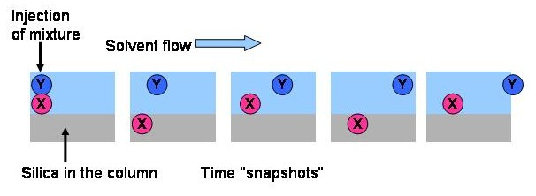
Figure 5 Schematic separation of a two component mixture

The technique that is usually used in HPLC is termed “reverse phase chromatography”. The stationary phase comprises silica with non-polar hydrocarbons chains attached whilst the mobile phase is predominately polar (water based). The solute molecules are held on the column by hydrophobic interactions with the stationary phase. It is the same principle by which grease is attracted to the fatty chains on soap and detergents. For example, compounds with lots of OH groups (polar) will come off the column faster than non-OH compounds (less polar). In contrast, for “normal phase” chromatography, the stationary phase has lots of OH groups, e.g. normal silica or paper (cellulose), and polar molecules stick to it.

The polarity of the solvent (mobile phase) can be modified by changing the ratio of water and organic solvents in the mixture. This allows the control of the affinity of the solutes for the stationary phase in relation to its affinity for the mobile phase. Therefore the speed at which each solute travels down the column can be controlled and hence a separation can be achieved.

Mass Spectrometry (MS)

The mass spectrometer is essentially another detector which is used to analyse the molecules that come off from the HPLC column. The MS provides precise information about the molecular mass of each of the components of a mixture. The mass spectrometer works by turning the molecules into ions, detecting them and then working out their mass The most common type of ionisation used in an HPLC-MS system is called electrospray ionisation (ESI).
The solution from the HPLC system flows into a stainless steel capillary which is contained within the electrospray probe. The capillary is surrounded by a flow of nitrogen gas and a spray is produced when the solution leaves the probe. A voltage is applied between the probe tip and a metal cone called the sampling cone. In the electrical field at the capillary tip, the surface of the droplets leaving the probe becomes charged, either positively or negatively, depending on the voltage polarity. The nitrogen gas flowing from the probe tip aids solvent evaporation, and so the droplets reduce in size. This consequently increases the charge density at the surface of the droplets. The repulsion forces between the charges increase until there is an explosion of the droplets. This process repeats until individual ions are formed. These are attracted towards the target (Figure 6).
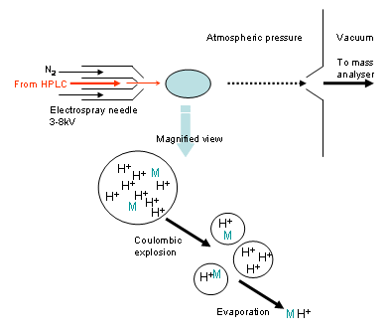

Figure 6 Formation of ions in an ESI mass spectrometer.

The typical ions produced by electrospray ionisation are [M+H]⁺ in the positive mode and [M-H]⁻ in the negative mode. The ions are then attracted towards the mass analyser which sorts the ions based on their m/z ratios. They then pass through to the detector.

If paracetamol is used as an example; its molecular formula is C₈H₉NO₂, which means its molecular weight is 151. Therefore, if paracetamol is analysed by electrospray ionisation (positive), the ion that would be observed is [151+H]⁺ = 152.
It is common to see a small peak due to [2M+H]⁺ (Figure 7).
0

300.00
400.00
500.00

700.00
800.00
900.00
1000.00
m/z
0
100
%
1:MS ES+
5.2e+007
1:(Time: 1.04) Combine (25:28-(17:19+36:39))
152.0
153.1
303.1
174.1
193.1
[M+H]⁺
[2M+H]⁺
Figure 7 Positive electrospray mass spectrum for paracetamol.

