NMR explained

**Nuclear Magnetic Resonance Spectroscopy explained**

4.0

3.5

3.0

2.5

2.0

1.5

1.0

0

1

2

3

4

5

6

7

8

9

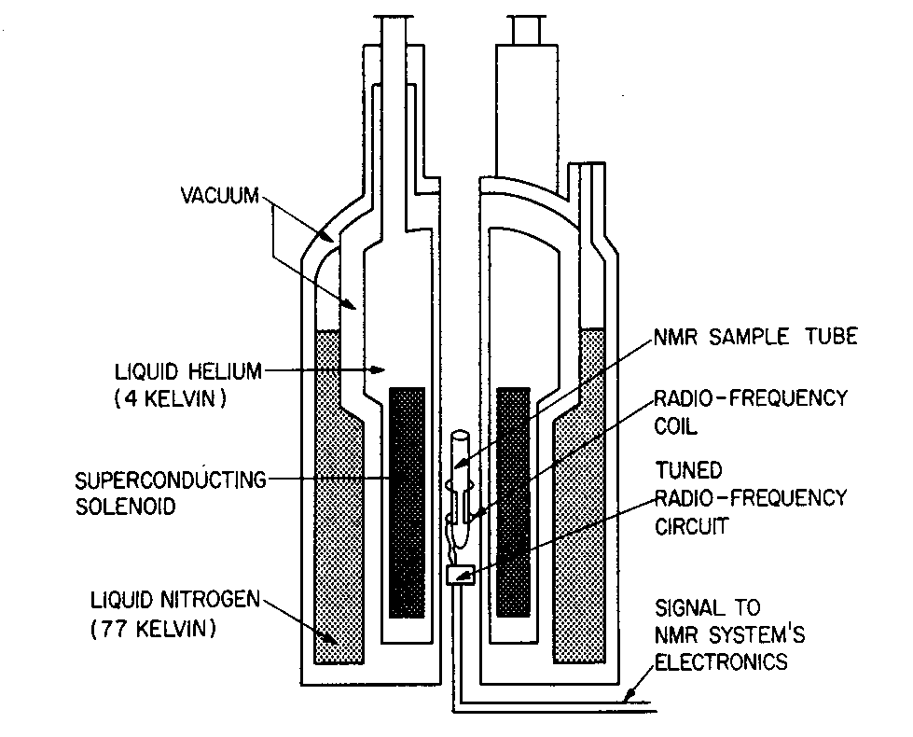

Discovered by physicists

(Nobel Prize 1952) but put to use by chemists

# Basic Principles of NMR

* Atomic nuclei “spin” (they possess intrinsic angular momentum in the quantum mechanical sense).
* This spin allows nuclei to produce a small magnetic field.
* An external magnetic field can therefore influence the magnetic properties of the nucleus.
* Hydrogen nuclei (protons) can spin in 2 directions. These are of equal energy at equilibrium.
* Note that some nuclei can only spin in one direction and are effectively invisible by NMR Spectroscopy.
* In an external magnetic field nuclei behave like small bar magnets, in that they can align **with** or **against** the field.
* In this situation the two spin states are of different energy ;
  + the lower energy state is where the nuclei are aligned with the field;
  + the higher energy state is where the nuclei are aligned against the field – directly opposite in direction.
* A good way to understand this is to compare a nucleus to the bar magnet of a compass. When it is in the Earth’s magnetic field it will always point *North-South*, as it is the most stable position. However the *South-North* position is also stable but it is very easy to push it to the more stable *North-South* position.
* If we put a sample in a strong magnetic field and then hit it with radiation in the radiofrequency (rf) range, a nucleus in the lower energy state can transfer to a higher one by absorbing radiation of the appropriate energy.
* If we switch off the irradiation the nuclei will fall back to the lower energy state and give out energy as a radiowave again.
* The frequency that a nucleus resonates can be influenced by many factors such as the electronegativity of surrounding atoms.
* Therefore, if a molecule contains several different types of 1H nuclei, they will be expected to **absorb** rf radiation at slightly different frequencies when excited. As they relax back to their lower energy states the different types of 1H nuclei will **emit** these different frequencies.

## How modern NMR spectrometers work

* Hydrogen atoms (or other nuclei such as 13C, 15N, 31P, 19F) in organic compounds are irradiated with a wide range of radiowave frequencies for about 10μsec. The protons absorb energy and there is an increase in the population of the higher energy state.
* The radio pulse is turned off (for about 1.5sec) and the protons give out discrete amounts of radio energy as they collapse back to equilibrium.
* The NMR spectrometer records all these emissions at the same time and uses complex mathematics (Fourier Transformation) to give the individual frequencies emitted in an interpretable form.
* The centre of the instrument contains a super conducting wire coil cooled with liquid helium. At 4K the super conducting coil has little electrical resistance and so a strong electromagnetic field can be produced without producing any heat. Other small additional magnetic coils are used to help to produce a perfectly homogeneous magnetic field. The sample is in solution in a glass tube which is spun round rapidly to even out imperfections.

**The Magnet**

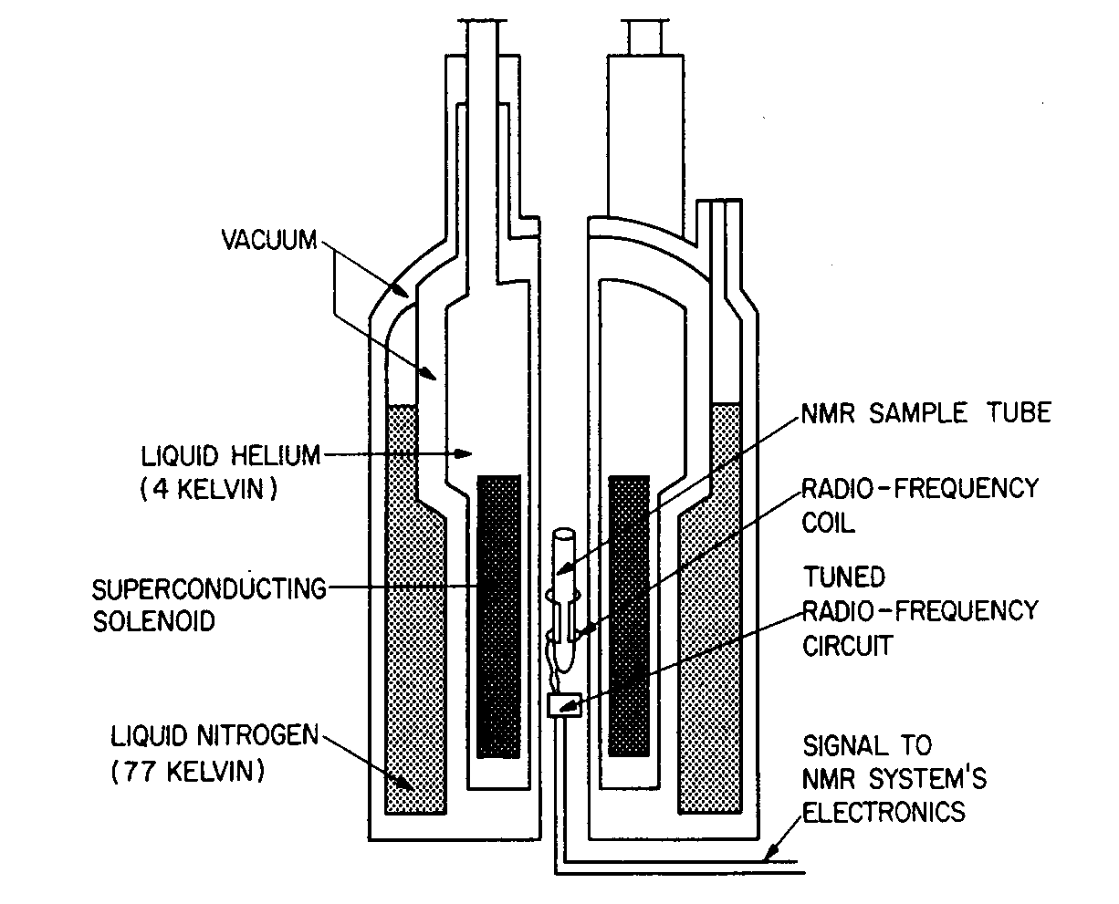

The magnet contains about 40km of super-conducting wire.

A 400Mhz machine costs about £200K;

the world’s biggest machine of 900Mhz costs about £7million

**Chemical Shifts**

* Each nucleus (or group of magnetically equivalent nuclei) resonates with a characteristic frequency, or chemical shift.
* Chemical shifts are given in units of parts per million (ppm).
* TMS (tetramethylsilane) (CH3)4Si is often used as an internal reference in sample solutions. The 1H chemical shifts in TMS are assigned a value of zero ppm.
* For proton NMR, the normal chemical shift range is 0 to 15 ppm.
* Different functional groups affect the chemical shifts of protons in different ways.
* By looking at the chemical shift of a proton we can gain information about the structure of a molecule



**Basic Principles of NMR - Integrals**

* hydrogen nuclei present.
* The spectrum is essentially a plot of the amount of radiation absorbed against frequency.
* The area under a given NMR signal (integral) is proportional to the number of nuclei giving rise to that signal.
* Apart from counting the number of protons from a molecule, integrals can also be used to measure the amount of solvents and/or impurities present in the sample.

**Spin-Spin Coupling**

* The line splittings observed in a proton’s NMR resonance signal result from coupling of other protons’ nuclear spins through covalent bonds.
* Other nuclei near to the proton being observed have their own magnetic fields (m) due to their spin and so the proton can see an overall magnetic field of the applied field (M) enhanced by its neighbours field (M+m) or reduced (M-m).
* This effect is only seen over short distances and so a proton will usually only couple with other protons on adjacent carbons along a chain.
* Couplings over greater distances can be seen in aromatic rings and other systems where the shape and orientation of the molecule permits longer range interactions.
* A proton with one neighbouring proton on an adjacent carbon is seen as a doublet as its neighbour can either add or subtract its small magnetic field (M+m or M-m).
* If a proton has two neighbours (1 and 2) it is seen as a triplet because there are three different fields possible (note that m1 and m2 are equal):

M + m1+ m2

M + m1-m2 or M - m1+ m2

and M - m1- m2

* This pattern continues with an increasing number of adjacent protons.
* In general, for 1H, ***n*** coupled nuclear spins will split the signal into (***n*** + 1) lines.
* The intensity of each of these signals is related to the number of combinations of the neighbours’ spins that give the same field i.e.;

M + m1-m2 is the same as M - m1+ m2,

* Therefore the centre of the triplet, having two combinations (as above), is twice as large as the two outer peaks which only have one way of adding the fields to give the overall magnetic field
* The relative intensities of the individual lines of a ***simple*** multiplet are given by Pascal’s Triangle:

**1 n = 0, one line (singlet)**

**1 1 n = 1, two lines (doublet)**

**1 2 1 n = 2 (triplet)**

**1 3 3 1 n = 3 (quartet)**

**1 4 6 4 1 n = 4 (pentet)**

* Protons have just two ways of spinning and so a good pictorial way of looking at them is to be spin up (↑) or spin down (↓).

1 : 3 : 3 : 1

1 : 1

CH3 doublet

CH2 quartet

* The diagram above shows the different combinations of spins that give rise to a signal’s multiplicity.
* Spin-spin coupling is very important to NMR, as this gives information about the group next to the one being observed, allowing you to work out a structure going from one signal to the next building it up as you go along.

**Spin-Spin Coupling – Example**



* By using the formula (multiplicity = n+1, where n = number of protons coupling to the observed signal) we can predict the multiplicities of the signals arising from ethanal (right).
* The three equivalent protons marked 1 are all coupled to just one proton, 2, and produce a signal with two peaks (doublet) of equal intensity.
* Proton 2 is close to other three other protons and is seen as a quartet with a ratio of 1: 3 : 3 : 1

**An NMR spectrum – Example 1**

* This is the NMR spectrum of ethanal (acetaldehyde).



* The chemical shift of the CH signal is typical of that of aldehyde protons, it integrates for a third as much as the doublet and is clearly a quartet, telling us it is near to 3 protons.
* The other signal is at a much higher chemical shift, as expected for a methyl group, it integrates for 3 times as many protons as the quartet, and is seen as a doublet which means it is coupling to just one proton.

**An NMR spectrum – Example 2**

* This is a spectrum of ethyl ethanoate (ethyl acetate).



* It contains three sets of signals, which all together tells us it what it is.
* Try to match up (assign) the NMR signals to the protons in the molecule.

**Summary**

* NMR spectroscopy is a very powerful tool in identifying the structure of molecules. It can distinguish between isomers with the same molecular formula but different structures.
* It can quantify how much solvent is present in a sample (e.g. from recrystallisation) and help identify impurities that are at low levels.
* Three important pieces of information are all given by the same NMR spectrum:
  + The Chemical Shift of a proton signal tells you its chemical environment
  + The Integral of an NMR signal tells you how many protons there are
  + The Spin-spin coupling tells you how many protons are in the groups nearby
* Other experiments, including obtaining 2 and 3 dimensional spectra are also performed by modern NMR spectrometers which can help look at larger molecules where some proton signals may be overlapping.