Climate change and communicable diseases.
Communicable diseases and pathogens:
Communicable diseases are infectious as they are caused by pathogens. Pathogens include bacteria, fungi, protozoa and viruses, and they are transmitted between people or animals to allow the disease to be spread. This transmission can occur via direct contact, by water or by air. Bacteria, fungi, protozoa and viruses all have different features and therefore, infect individuals using different mechanisms.

Virus: 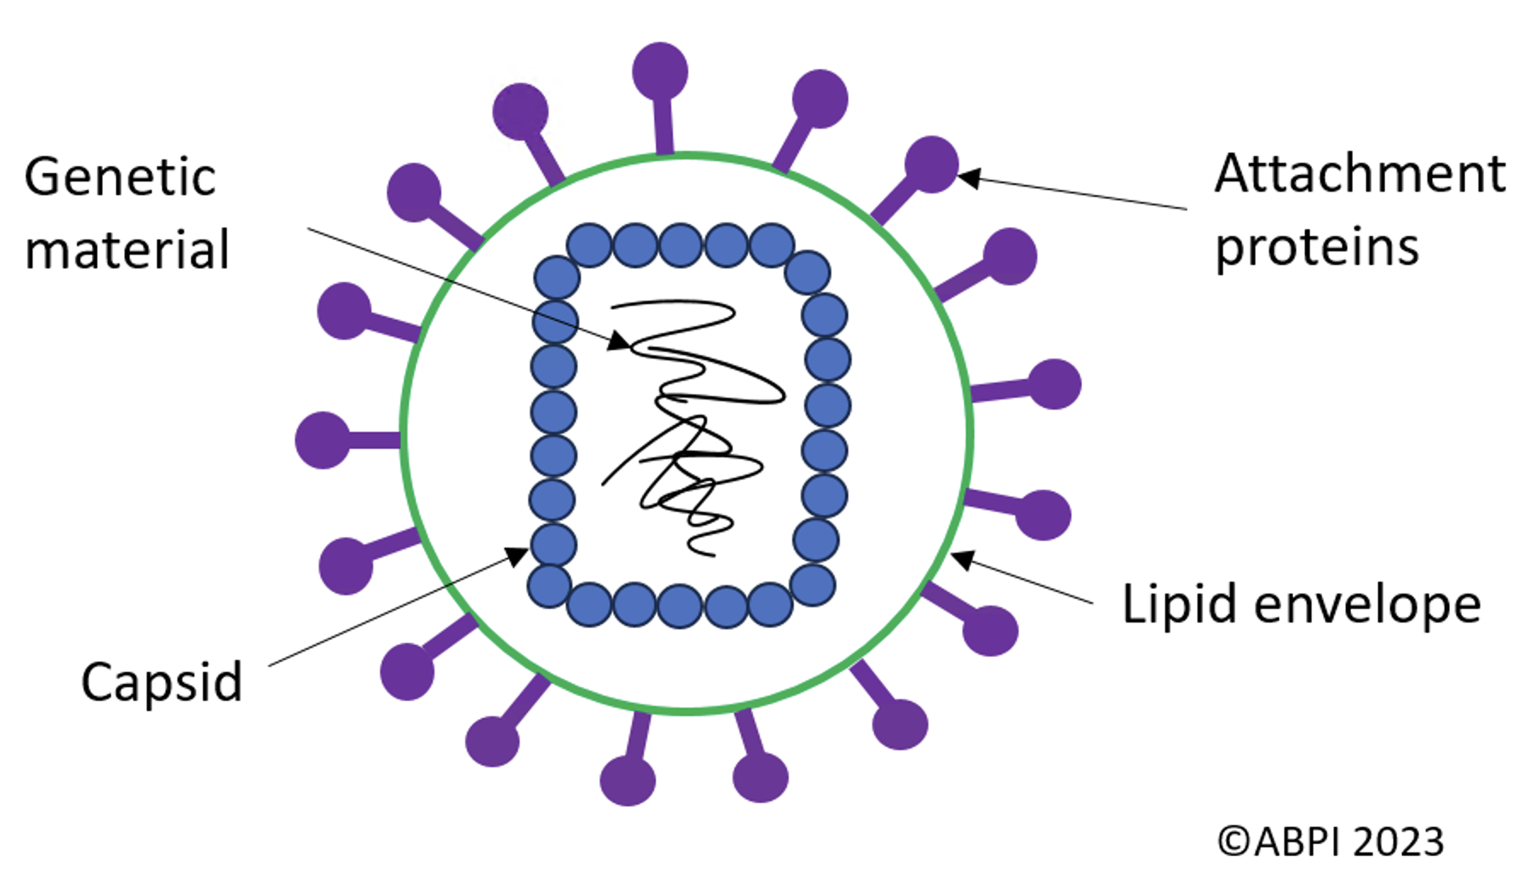
Figure 1: The structure of viruses.

Figure 1 shows the structure of a virus. Viruses are much smaller than bacteria. Also, unlike bacteria, fungi and protozoa, viruses are non-living, being made up of just genetic material, a capsid and attachment protein. They are classed as non-living since they cannot reproduce independently; viruses must invade a host cell and use it’s replication machinery to make copies of itself. Sometimes viruses also contain a lipid envelope (surrounding the capsid) and this is made from the host cell membrane as the virus is released.
To infect a host cell the virus first attaches to the host via their attachment proteins. The attachment proteins bind to receptors on the surface of the host cell, in a very specific interaction. Once the virus attaches, it can then enter the host cell and release it’s genetic material which becomes replicated, transcribed and translated by the host cell machinery. This sequence of events leads to production of new viral proteins, which are reassembled to form new viral particles. These viral particles are then released from the host cell, causing host cell lysis.
Bacterium:
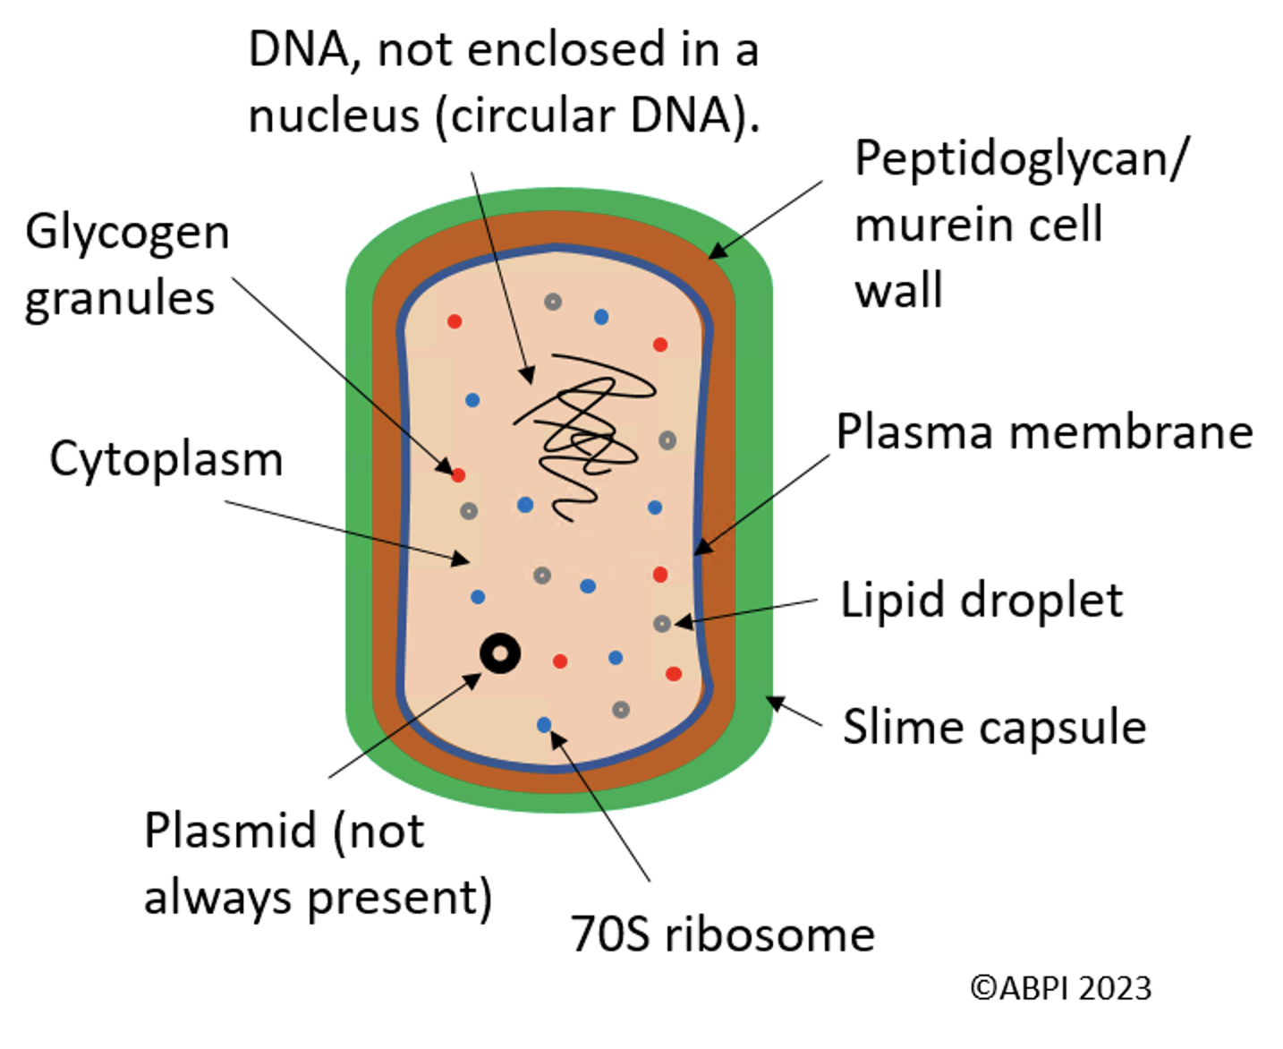
Figure 2: The structure of a bacterial cell.
Figure 2 shows the structure of a typical bacterial cell. These are prokaryotic cells, which are smaller than eukaryotic (animal) cells. Prokaryotic cells have no membrane bound organelles (including nucleus) meaning that the DNA is free in the cytoplasm. The DNA is not histone bound either. Some bacterial cells also contain plasmids, which are small loops of DNA, often carrying antibiotic resistance genes that can be transferred between cells for survival via pili (not shown). Pili are hair like projections on the surface of the bacterial cell, allowing the cell to stick to surfaces and transfer genetic material to other bacterial cells. Like eukaryotic cells though, bacterial cells also contain ribosomes for protein synthesis. These are smaller than in eukaryotic cells and are known by scientists as 70S ribosomes. The prokaryotic cell wall is made of peptidoglycan/murein, needed for protection, and this is sometimes encased in a slime capsule to prevent phagocytosis. The glycogen granules and lipid droplets are nutrient stores. Some bacterial cells also contain one of more flagella (not shown), which are needed for movement.
You can find out more about bacteria and viruses in the pathogens resource, and more information on specific infectious diseases that they can cause in the diseases resource.

Routes of transmission:
There are various routes of transmission for the spread of communicable diseases:
- Direct contact: direct contact between person to person or people and animals can lead to the spread of communicable diseases. This can include physical touch or animal bites, as examples. Sharing of bodily fluids, such as saliva, can also be responsible for direct transmission.
- Indirect contact: Pathogens can also survive on surfaces, and individuals can then become infected by touching a contaminated surface. If an individual touches a contaminated surface and then touches their mouth or eyes, they can also become infected.
- Blood borne transmission: contaminated blood can be transferred between individuals, either through needle stick injuries, sharing needles, or through blood transfusion. For example, hepatitis B and C, as well as HIV, are common blood borne diseases.
- Airborne transmission: some diseases are spread through the air, as pathogens can be suspended in the air and then inhaled by another individual. This includes diseases such as influenza and tuberculosis.
- The faecal-oral route: diseases can be spread by consuming contaminated food or water. Water becomes contaminated with faecal matter due to inadequate water treatment or sewage overflow (as examples) and this can be either directly consumed or used to wash food, contaminating the food too, resulting in the disease being spread when the food is consumed.
- Food borne transmission: as well as food becoming contaminated through washing with contaminated water, food itself can transmit infection. Salmonella is a common food borne disease.
- Vector borne transmission: A vector is usually an arthropod, such as a mosquito or a tick. Vectors can transmit pathogens between hosts through their bites. Examples of vector borne diseases include malaria and dengue fever.

Treating communicable diseases and the body’s defences:

When the body is infected with a communicable disease, it fights back via the immune system to fight off the infection. Modern medicine has also developed many successful treatments to assist the body’s natural defences, including antibiotics.
Antibiotics can treat bacterial infections in two ways, depending on whether they are bacteriostatic or bactericidal antibiotics.
- Bacteriostatic antibiotics: Prevent the growth and replication of the bacteria
- Bacteriocidal antibiotics: Kill the bacteria
Different bacterial pathogens are killed by different antibiotics, and so doctors should make sure to choose the right one when prescribing them to patients.
Antibiotics cannot cure communicable diseases caused by viral pathogens, since viruses replicate inside the human cells; for this reason, virus particles are hard to access with drugs. Instead, viruses are more commonly managed through vaccination (though some antiretroviral drugs are available). You can find more out information about different medicines for communicable diseases in the medicines resource.

Climate change and communicable diseases:
Cholera:
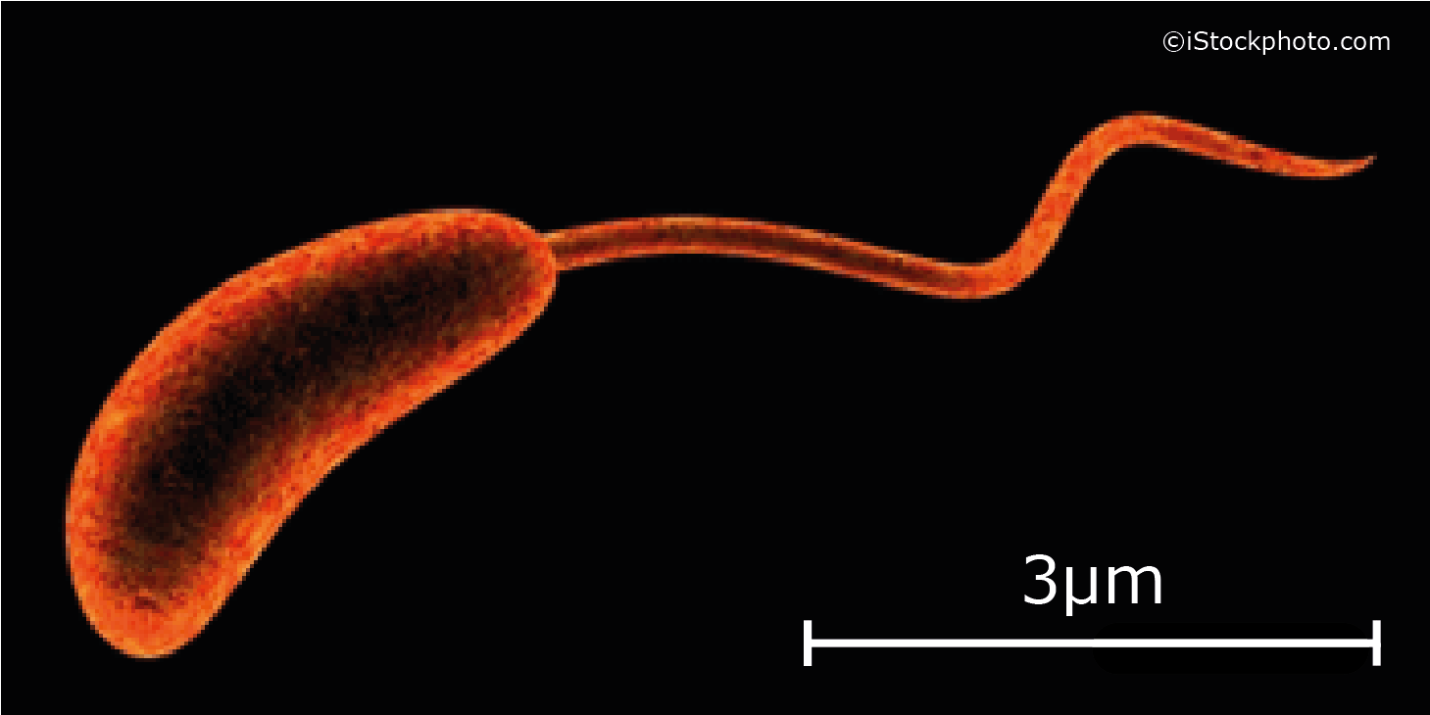
Climate change is making some communicable diseases more common, especially in poorer countries. For example, cholera (caused by the bacterium Vibrio cholerae) is a communicable disease which is commonly spread through the faecal-oral route, by drinking water which is contaminated or by eating seafood or vegetables which have been washed in contaminated water. It affects the intestinal tract.
Climate change has led to an increase in the incidence of cholera, and this is for a few reasons.
Figure 3: A Vibrio cholerae bacterium.
- Firstly, the increased water temperatures provide ideal conditions for the growth and survival of cholera, making water contamination more likely.
- Altered rainfall patterns have an impact too, with both extreme heavy rain and droughts being responsible. Heavy rain can cause flooding which means that sewage can contaminate water sources. However, droughts lead to water scarcity which increases the need to be dependent on contaminated water sources to drink.
Malaria, zika and dengue:
Malaria, zika and dengue infections are also on the rise due to climate change. These are all vector-borne diseases, meaning that they are transmitted by a vector organism (in this case, mosquitos). This is because changing climates mean that the vectors (mosquitos) can survive in areas where they couldn’t previously, making the geographical range with the possibility of infection, larger. The warmer temperatures can also increase the reproduction of mosquitos by altering their life cycle, increasing the number of vectors. This means that the possibility of infection is higher.
Malaria is caused by the Plasmodium parasite, which is eukaryotic, and zika and dengue are caused by viral pathogens.
Recommended independent research:
- Why do you think that less economically developed countries experience a higher incidence of water-borne communicable diseases?
- Are the countries directly affected by the increased communicable disease incidence those which contribute the most to greenhouse gas emissions?
- Are there treatment options for the above communicable diseases?
- How do natural disasters impact these communicable diseases, and how is this linked to climate change?
- Climate change is not the only factor influencing communicable disease incidence. What other factors are there? How can these other factors be used to control the incidence of communicable disease, regardless of climate change?

