The impact of climate change on health: asthma.

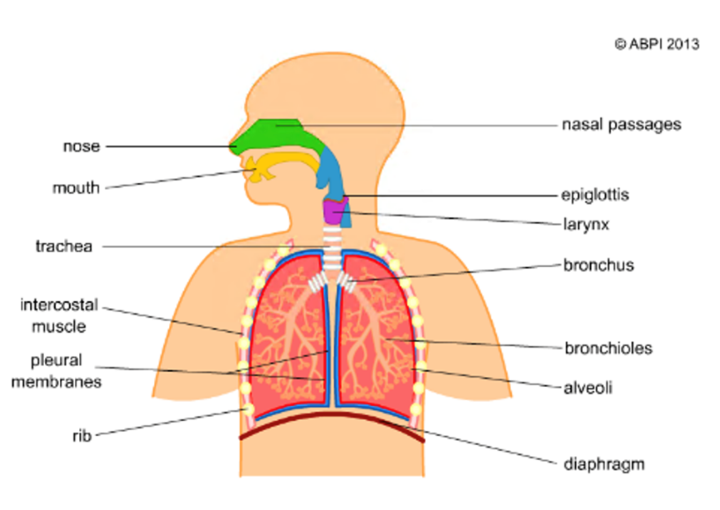
Structures of the breathing system:

Mammals have a specialised breathing system which makes sure that oxygen is brought into the body and that carbon dioxide is removed. The breathing system is also known as the respiratory system, but this is NOT the same as respiration. Respiration takes place in the cells and breathing takes place in the airways and the lungs.

Figure 1 shows all the structures of the breathing system.
Figure 1: A simple model of the human breathing system.

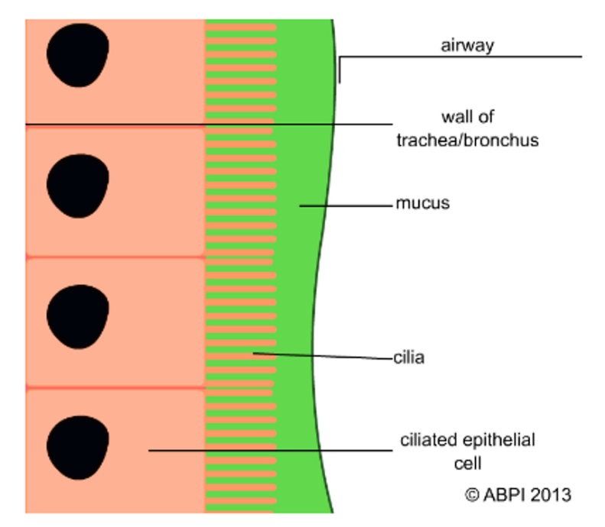

Crucially, the structures of the breathing system are lined with ciliated epithelial cells which move mucus, dirt, and pathogens out. This helps to protect the lungs from disease and ensures that the main structures do not get blocked with mucus, as this would make breathing less efficient.

Figure 2 shows ciliated epithelial cells lining tracheal/bronchial walls.

Figure 2: Ciliated epithelial cells move mucus, dirt, and pathogens out of the breathing system, protecting the lungs from damage and disease.

Breathing:

For your breathing system to work successfully, you need to move air into your lungs (inhalation) and then move air out again (exhalation). This is known as breathing or ventilation.
To move air into or out of the lungs the relationship between the air pressure in the lungs and atmospheric air pressure is changed. These changes are brought about by movements of your ribs, which you can see and feel, and by movements of your diaphragm, which you cannot. The breathing movements change the volume of your chest, which in turn affects the air pressure inside the lungs and causes air to move passively in or out.

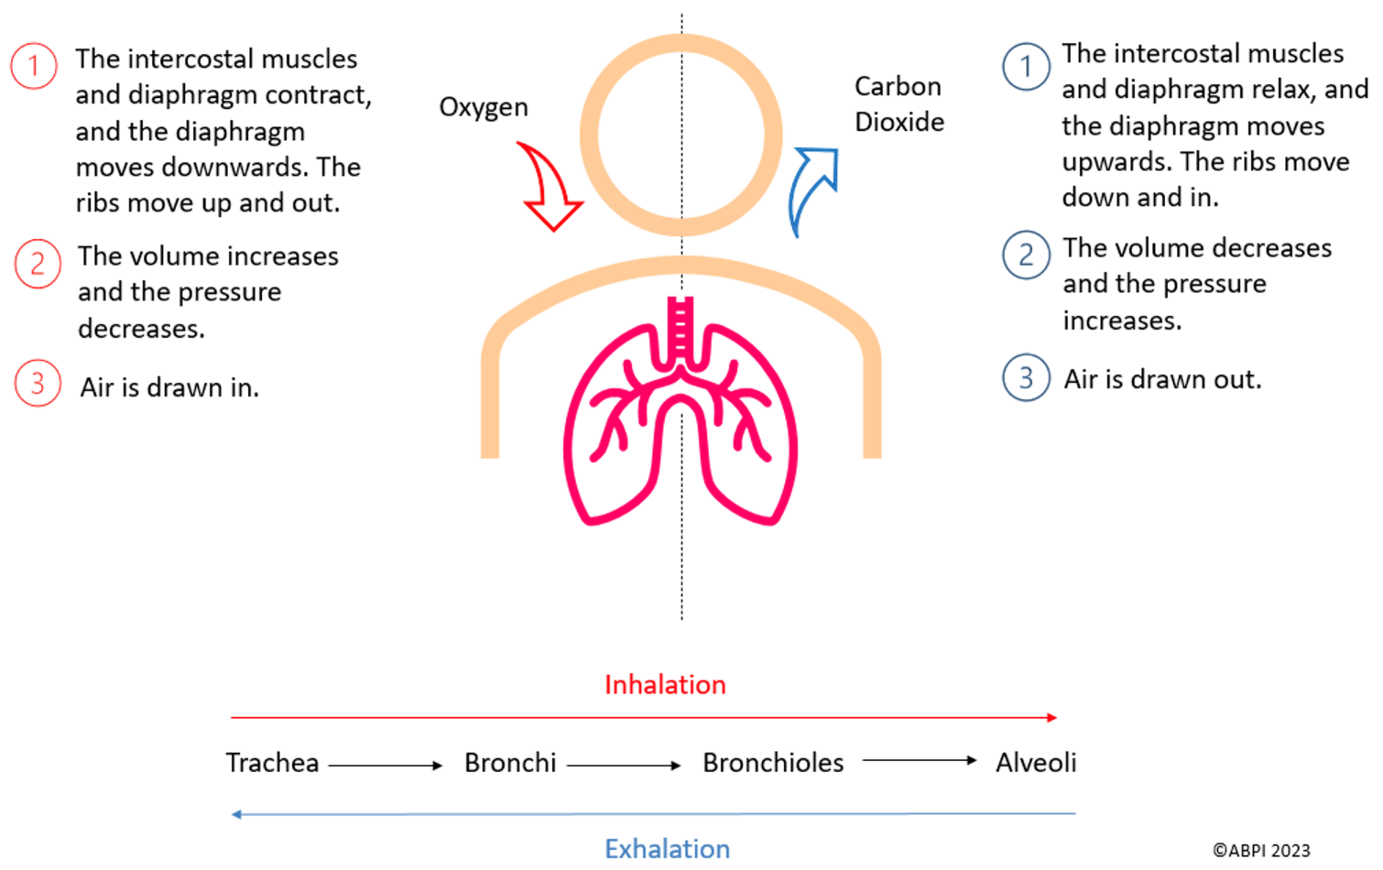
Figure 3 describes the process of inhalation (left) and exhalation (right).
Figure 3: Inhalation and exhalation.

Gaseous exchange:

Gaseous exchange is the exchange of gases between two areas, and this is NOT the same as breathing. However, breathing is required for gaseous exchange to occur.

Gaseous exchange includes the diffusion of gases between the air in the alveoli of the lungs and the blood, as well as the blood and the cells of the body. The lungs are the site of gaseous exchange in mammals and so they have adapted over time to ensure that the process is efficient. You can find out more about gaseous exchange and the adaptations of the lungs in the gaseous exchange resource, but to summarise, the alveoli have a high surface area to volume ratio which is advantageous. Alveoli also have a rich blood supply, helping to maintain the concentration gradient required for gaseous exchange. Additionally, alveoli have very thin walls, meaning that gases do not have to diffuse far for gaseous exchange to take place.

Asthma:

Asthma is a condition which makes the bronchioles become inflamed and constricted.
This causes the airways of the lungs to narrow meaning that patients have difficulty breathing.

People with asthma have over-sensitive airways that become irritated by triggers such as pollen, house dust mites, pet hairs, exercise, smoke or even cold air. Asthma can also be triggered by stress. Someone who has asthma isn’t affected all the time. They may have attacks several times a day or only a few times a year.

During an asthma attack the cells lining the bronchioles release chemicals called histamines. Histamines cause the lining of the cells to become inflamed and can make the cells produce large amounts of mucus and swell. As asthma can also cause a depletion of ciliated epithelial cells, and because there is hypersecretion of mucus by goblet cells, mucus gets trapped in the airways. Histamines also make the muscles in the walls of the bronchioles contract. As a result of these changes the airways narrow, making it very difficult for air to move into and out of the lungs (ventilation).

Figure 4 displays the difference between normal and asthmatic bronchial tubes.

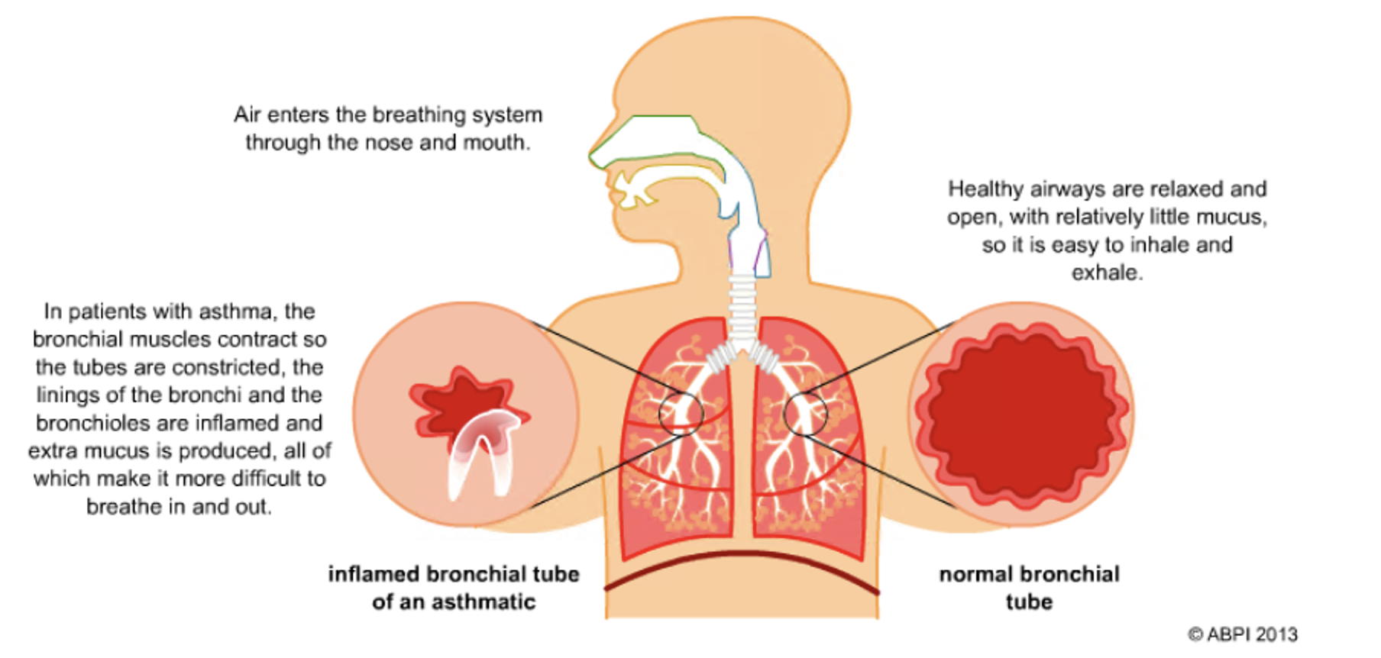
Figure 4: The difference between normal and inflamed bronchial tubes.

These changes can lead to a tight chest and shortness of breath which therefore, means that gaseous exchange is reduced, but indirectly. The tight chest reduces the efficiency of the breathing system, so there is insufficient airflow into and out of the alveoli. This results in poor gaseous exchange, even though the alveoli themselves are functional.

How is asthma managed?

Asthma can be managed by using an inhaler which contains a steroid medicine. The medicine is administered into the lungs, and this can help to reduce the inflammation and widen the airways again. Inhalers can also contain a β2-agonist which can help to relax the muscles in bronchial walls.

How anthropogenic activity is correlated with asthma:

Asthma is becoming more common due to increased pollutants, and those with asthma are getting symptoms more often. In fact, the NHS state in their Net Zero Strategy that cutting emissions will help to reduce up to 1/3 of new asthma cases.

This is partly due to longer pollen seasons. Pollen is a common allergen released from plants which can trigger asthma attacks in asthmatic patients (due to histamine release). As temperatures increase and the seasons shift, pollen is more prevalent and this can worsen asthma.

Air pollution has also been found to be responsible for an increase in asthma cases. In 2017, doctors in Delhi estimated that particulate matter which is smaller than 2.5 micrometers (PM2.5) can have the same effect as smoking 50 cigarettes a day, and that it can lead to pneumonia, lung cancer and asthma.

You can learn more about the biological impact of smoking on the breathing system, and therefore PM2.5, on the breathing system in the smoking resource.

The impact of asthma management on the environment:
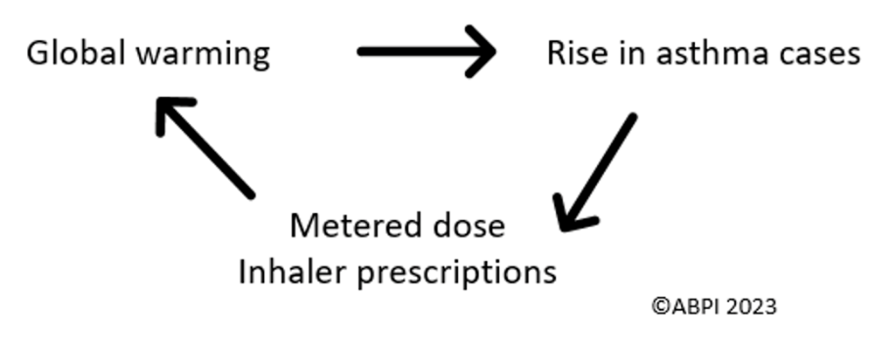
As asthma symptoms are on the rise, the prescription of inhalers has also risen. However, inhalers themselves contribute to global warming, as they contain a greenhouse gas propellant (these are known as metered-dose inhalers). The NHS estimates that inhalers are the largest emission source of all medicines, along with anesthetics, and that medicines account for 25% of their total carbon footprint.
Figure 5: The self-perpetuating cycle between global warming and asthma management.

However, asthmatic patients need to continue to use their inhalers to manage their symptoms, and so the pharmaceutical industry has a responsibility to develop new medicines which manage symptoms as effectively, whilst being kinder to the planet.

Recommended independent research:
- What are the World Health Organisation air quality guidelines and how are these associated with asthma?
- What are pharmaceutical companies doing to help reduce the impact of inhalers throughout their life cycle? Companies have sustainability and net zero goals which are aligned to the Science Based Targets Initiative, allowing them to reduce emissions in line with the Paris Agreement goals. You will be able to find out more information about individual initiatives on company websites, and you can find a list of pharmaceutical companies in the ABPI members list.
- What is the National Institute for Health and Care Excellence asthma patient decision aid? How will this help to reduce greenhouse gas emissions associated with inhaler use?

