Classification of living organisms
Key definitions – Activity

Match each word with the correct definition.
Draw a line between each word on the left and the corresponding definition on the right.

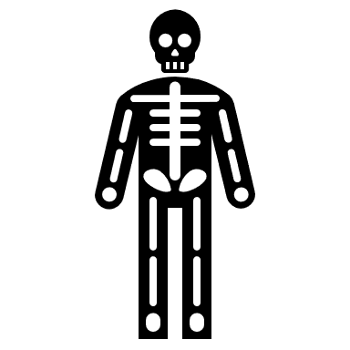 | Organism | • | • | The process of grouping things together based on shared features.
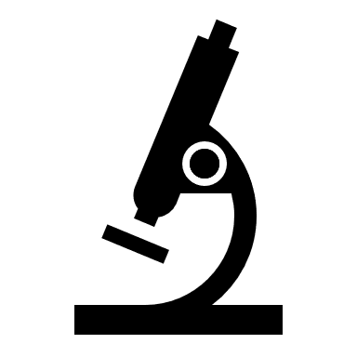 | Microscope | • | • | Any form of life, including animals, plants, fungi and microorganisms.
 | Plant | • | • | A very small organism that cannot be seen with the naked eye. These tiny organisms are about a million times smaller than us!
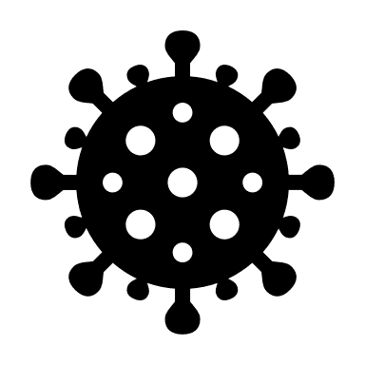 | Microorganism (or Microbe) | • | • | An organism that can make its own food using sunlight but cannot move around.
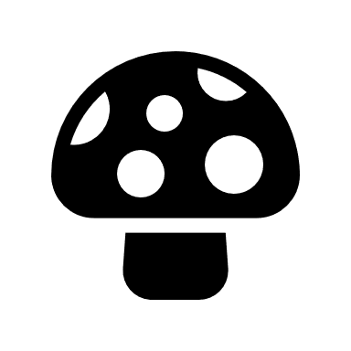 | Mushroom | • | • | A device that makes small objects look larger. It is similar to a magnifying glass, but a lot more powerful.
 | Classification | • | • | An organism that can move around and feed on other living things.
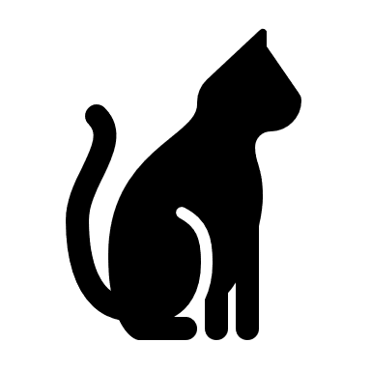 | Animal | • | • | A form of fungus that looks like a small umbrella. Fungus is a family of organisms, different from animals and plants.

